Resultados mediciones 2023

Maximiliano Zorian

## perdidas

# A tibble: 36 × 4  
# Groups: tratamiento, variedad [10]  
 tratamiento variedad bloque vivas  
 <fct> <fct> <fct> <dbl>  
 1 C CG08 1 50   
 2 C CG08 2 41.7  
 3 C CG08 3 33.3  
 4 C CG09 1 69.4  
 5 C CG09 2 52.8  
 6 C CG09 3 61.1  
 7 C Edunni 1 41.7  
 8 C Edunni 2 75   
 9 C Edunni 3 75   
10 C H105 1 33.3  
# ℹ 26 more rows

# Altura

# A tibble: 5 × 4  
 variedad media desvio n  
 <fct> <dbl> <dbl> <int>  
1 CG08 9.44 4.76 202  
2 CG09 8.53 5.07 180  
3 Edunni 6.35 3.70 161  
4 H105 7.00 4.87 202  
5 H117 7.34 2.90 236

# A tibble: 2 × 4  
 tratamiento media desvio n  
 <fct> <dbl> <dbl> <int>  
1 C 4.90 2.83 298  
2 T 9.01 4.43 683

# A tibble: 10 × 5  
# Groups: variedad [5]  
 variedad tratamiento media desvio n  
 <fct> <fct> <dbl> <dbl> <int>  
 1 CG08 C 5.96 3.09 63  
 2 CG08 T 11.0 4.55 139  
 3 CG09 C 3.50 1.65 42  
 4 CG09 T 10.1 4.76 138  
 5 Edunni C 3.25 1.72 39  
 6 Edunni T 7.34 3.62 122  
 7 H105 C 3.61 1.67 62  
 8 H105 T 8.50 5.06 140  
 9 H117 C 6.37 3.01 92  
10 H117 T 7.96 2.67 144

numDF denDF F-value p-value  
(Intercept) 1 10 131.80436 <.0001  
variedad 4 8 2.61401 0.1153  
tratamiento 1 10 116.51519 <.0001  
variedad:tratamiento 4 10 2.26476 0.1343

Shapiro-Wilk normality test  
  
data: resid(mALT_nl)  
W = 0.96443, p-value = 0.3998

Levene's Test for Homogeneity of Variance (center = median)  
 Df F value Pr(>F)  
group 9 0.241 0.9834  
 20

# Modelo

Sin el bloque 4 y sin el control de manejo

numDF denDF F-value p-value  
(Intercept) 1 8 107.27034 <.0001  
variedad 4 8 2.87864 0.0949

Analysis of Variance Table  
  
Response: media  
 Df Sum Sq Mean Sq F value Pr(>F)   
bloque 2 13.637 6.8183 2.9590 0.10916   
variedad 4 26.533 6.6332 2.8786 0.09491 .  
Residuals 8 18.434 2.3043   
---  
Signif. codes: 0 '***' 0.001 '**' 0.01 '*' 0.05 '.' 0.1 ' ' 1

Shapiro-Wilk normality test  
  
data: resid(mALT_nl)  
W = 0.91786, p-value = 0.1787

Levene's Test for Homogeneity of Variance (center = median)  
 Df F value Pr(>F)  
group 4 0.4185 0.7919  
 10

## Graficos

Tratado y control

Todos los bloques 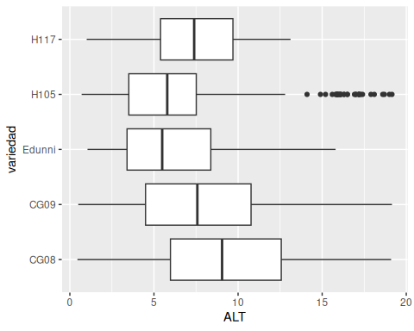

* Sin el bloque 4 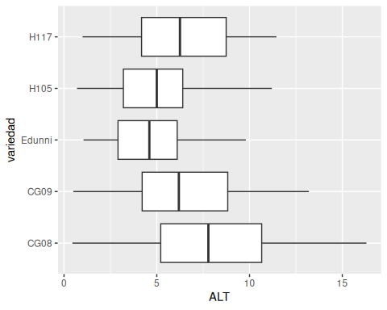
* Solo Tratado

Todos los bloques 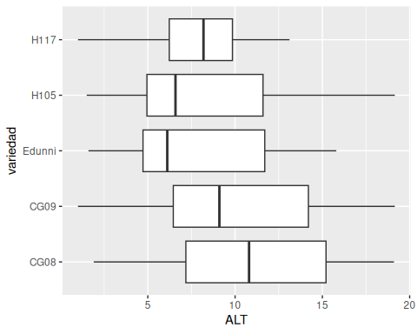

Sin el bloque 4 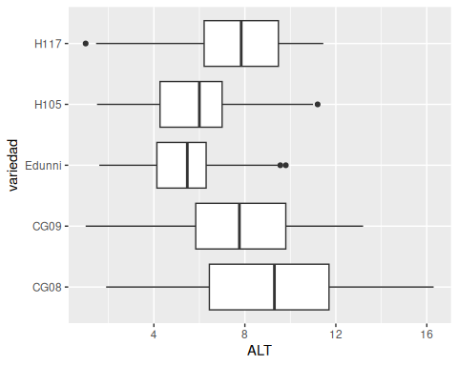

contrast estimate SE df t.ratio p.value  
 CG08 - CG09 1.4545 1.24 8 1.174 0.2743  
 CG08 - Edunni 3.6201 1.24 8 2.921 0.0193  
 CG08 - H105 3.2657 1.24 8 2.635 0.0300  
 CG08 - H117 1.4249 1.24 8 1.150 0.2835  
 CG09 - Edunni 2.1657 1.24 8 1.747 0.1187  
 CG09 - H105 1.8112 1.24 8 1.461 0.1821  
 CG09 - H117 -0.0296 1.24 8 -0.024 0.9815  
 Edunni - H105 -0.3544 1.24 8 -0.286 0.7822  
 Edunni - H117 -2.1953 1.24 8 -1.771 0.1145  
 H105 - H117 -1.8408 1.24 8 -1.485 0.1758  
  
Degrees-of-freedom method: containment

variedad emmean SE df lower.CL upper.CL .group  
 CG08 8.94 1.03 2 4.487 13.38 A   
 H117 7.51 1.03 2 3.062 11.96 AB   
 CG09 7.48 1.03 2 3.033 11.93 AB   
 H105 5.67 1.03 2 1.222 10.12 B   
 Edunni 5.32 1.03 2 0.867 9.76 B   
  
Degrees-of-freedom method: containment   
Confidence level used: 0.95   
significance level used: alpha = 0.1   
NOTE: If two or more means share the same grouping symbol,  
 then we cannot show them to be different.  
 But we also did not show them to be the same.

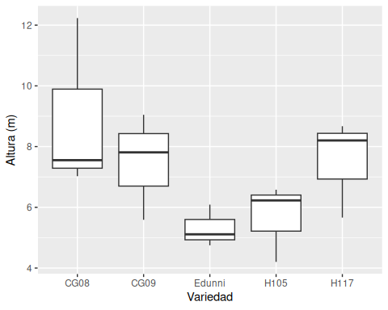

### Analisis de contrastes

Matriz de contraste, a partir de los tratados (con )bajo manejo: subsolado y fertilización) se compara:

1. El mejor clon (CG08) vs de semilla (Edunni)
2. Promedio de respuesta de clones vs de semilla
3. Clones HH vs GC

contrast estimate SE df t.ratio p.value  
 C1 -1.454 1.24 8 -1.174 0.2743  
 C2 -2.441 0.98 8 -2.491 0.0374  
 C3 -0.384 1.75 8 -0.219 0.8321  
  
Degrees-of-freedom method: containment

variedad emmean SE df lower.CL upper.CL .group  
 Edunni 5.32 1.03 2 0.867 9.76 a   
 H105 5.67 1.03 2 1.222 10.12 a   
 CG09 7.48 1.03 2 3.033 11.93 ab   
 H117 7.51 1.03 2 3.062 11.96 ab   
 CG08 8.94 1.03 2 4.487 13.38 b   
  
Degrees-of-freedom method: containment   
Confidence level used: 0.95   
significance level used: alpha = 0.1   
NOTE: If two or more means share the same grouping symbol,  
 then we cannot show them to be different.  
 But we also did not show them to be the same.

# DAP

# Modelo

* Sin bloque 4 y solo tratados

$bloque  
bloque  
1 2 3 4   
5 5 5 0   
  
$variedad  
[1] 3

numDF denDF F-value p-value  
(Intercept) 1 8 1.469127 0.2601  
variedad 4 8 1.031252 0.4474

Analysis of Variance Table  
  
Response: media  
 Df Sum Sq Mean Sq F value Pr(>F)  
bloque 2 23133 11566.7 2.1373 0.1804  
variedad 4 22324 5581.1 1.0313 0.4474  
Residuals 8 43296 5412.0